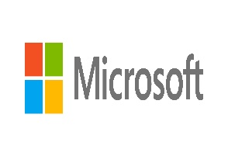
Dear Student.

We got your contact through your school database and we are very happy to let you know that our prestigious technology firm Microsoft Industries is running a special program to help out hard working students like you. We would like to set you up with a part-time remote job that you will have to do only five hours per week with a very handsome weekly pay. Please click on this link (link placeholder) to create your profile and enter the information requested if you are interested in this position.

Kind Regards
The Microsoft Tech Team

